Moska

Dowlatzay

ASSISTANT Manager

[moskadowlatzay@hotmail.com](mailto:moskadowlatzay@hotmail.com) 07488702371 [www.linkedin.com/in/moska-dowlatzay](http://www.linkedin.com/in/moska-dowlatzay)

**PERSONAL STATEMENT**

Dedicated and results-driven Junior front-end web developer. With a proven track record of effectively managing day-to-day operations, optimizing customer service, and driving team performance. Adapt at implementing strategic initiatives to enhance overall efficiency and profitability. Excels in staff training, inventory management, and maintaining high-quality service standards. Currently completing a bootcamp in front-end web developer with EdX which I’m thoroughly enjoying.

EXPERIENCE

June 2022 - Current

# Assistant manager- Food and wine express ltd

An assistant manager in a mini supermarket for just over a year, I have gained valuable experience in overseeing the day-to-day operations and ensuring the smooth functioning of the shop. My responsibilities include managing staff, handling customer inquiries and complaints, monitoring inventory levels, and assisting in implementing marketing strategies to increase sales.

In my role, I have successfully supervised a team of employees, ensuring they provide excellent customer service and maintain a clean and organized store environment. I have also assisted in implementing efficient inventory management systems, ensuring that products are well-stocked and minimizing waste.

Throughout my tenure, I have demonstrated strong leadership skills, problem-solving abilities, and a customer-focused approach. I am skilled at multitasking and thrive in fast-paced environments. I am also proficient in using various software and technology platforms to streamline operations and enhance productivity.

Overall, my experience as an assistant manager in a mini supermarket has equipped me with the skills and knowledge necessary to effectively contribute to the success of the store. I am confident in my ability to handle the challenges of the role and continue to drive growth and profitability.

October 2012- October 2012

# HR assistant- CBS Outdoors (work experience)

As a HR assistant at CBS Outdoors, my primary responsibility was to input all past and current employee files onto the online database. During my two-week tenure, I successfully completed this task, ensuring that all employee information was accurately recorded and easily accessible.

In this role, I meticulously organized and digitized employee files, including personal information, employment contracts, performance evaluations, and any relevant documentation. I ensured that all data was entered accurately and maintained strict confidentiality and data protection protocols.

Additionally, I collaborated with the HR team to verify the accuracy of the information and cross-reference it with existing records. I also assisted in creating a standardized filing system to ensure consistency and ease of access for future reference.

Throughout this process, I demonstrated attention to detail, organizational skills, and the ability to work efficiently to meet deadlines. I also maintained open communication with the HR team to address any questions or concerns that arose during the data input process.

Overall, my experience as an HR assistant at CBS Outdoors allowed me to contribute to the organization's goal of transitioning to an online database for employee records. I am confident in my ability to handle similar tasks in the future and contribute to the smooth functioning of HR operations.

November 2012- March 2014

**Customer service assistant**- Neasden foods ltd

As a customer service assistant at Neasden Foods Ltd, my role involved providing excellent customer service and ensuring customer satisfaction. I was responsible for assisting customers with their inquiries, processing transactions, and maintaining a clean and organized store environment.

During my time at Neasden Foods Ltd, I developed strong communication and interpersonal skills, allowing me to effectively interact with customers and address their needs. I provided product information, answered questions, and resolved any issues or complaints in a timely and professional manner.

Furthermore, I actively participated in maintaining store cleanliness and adhering to health and safety regulations. I ensured that the store was well-presented, organized, and free from any hazards that could potentially affect customers or staff.

Throughout my time as a customer service assistant at Neasden Foods Ltd, I consistently demonstrated a positive and friendly attitude, a strong work ethic, and the ability to work well within a team. I am confident in my ability to provide exceptional customer service and contribute to the success of the company.

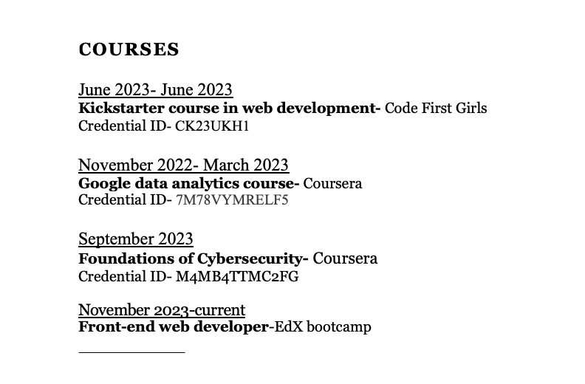

education

Sep 2004- July 2009

## GCSE- Camden school for girls

* Religious education- A
* Textiles- B
* English language- C
* English literature- C
* Science applied- C
* Science additional- C
* French- C
* Mathematics- D